OBJECTIVE QUESTIONS — FINAL ANSWERS

1. What is the total number of attributes present in the data?
Excel Method:
Count the number of columns in the final cleaned Tickets dataset.
Formula (optional):
=COUNTA(Tickets[[#Headers],[Agent ID]:[Seniorty]]) + COUNTA(IT_Agents[#Headers])
Output:
Total attributes in both sheet(columns) = 19
Total attributes in Ticket sheet(columns) =10
Snippet:
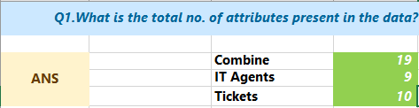
Insight:
The dataset contains sufficient attributes covering ticket details, agent information, resolution metrics, and demographics.

2. Which columns have inconsistent or missing values, and what is the count of such values?
Excel Method Used:
Applied filter and text validation on categorical columns.
Used COUNTIF to identify spelling variations.
Used COUNTBLANK() to verify missing values.
Formula Example (for missing values check):
=COUNTBLANK(Tickets[Seniority])
Findings (Inconsistencies Identified):
Column | Incorrect Value | Corrected To | Count
Severity | Unclasified | Unclassified | 356
Priority | Unassiged | Unassigned | 29,410
Severity | MayorF | Major | 4,836
Output Summary:
No true blank (NULL) values were found.
Multiple spelling inconsistencies existed in categorical columns.
These inconsistencies were cleaned and standardized for accurate analysis.
Snippet:
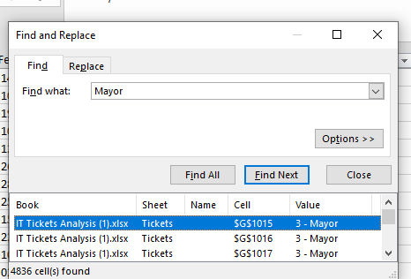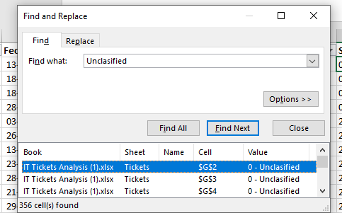
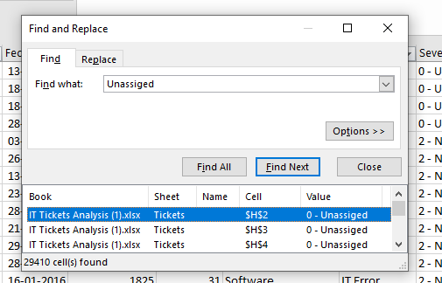
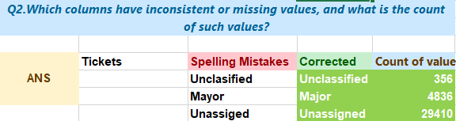
Insight:
The dataset initially contained data quality issues due to spelling inconsistencies, not missing values. Correcting these ensured reliable pivot tables, aggregations, and visualizations.

3. What is the average daily ticket volume over time?
Excel Method:
Pivot Table grouped by Date, counting tickets per day.
=AVERAGE(B14:B1840)
Pivot Setup:
Rows: Date
Values: Count of ID Ticket
Output:
Daily ticket volumes (e.g., 28, 43, 37, 36…)
Snippet:
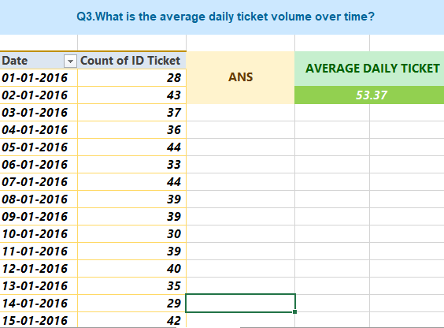
Insight:
Ticket volume fluctuates daily, indicating varying operational demand.

4. What is the distribution of ticket categories (e.g., Login Access, System, Software)?
Excel Method:
Pivot Table on Request Category.
Pivot Setup:
Rows: Request Category
Values: Count of Request Category
Output:
Hardware: 9,733
Login Access: 29,193
Software: 19,570
System: 39,002
Snippet:
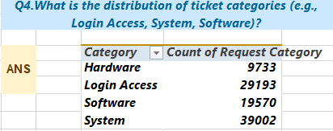
Insight:
System and Login Access issues dominate the workload.

5. How many tickets has each agent handled?
Excel Method:
Pivot Table by Agent ID.
Pivot Setup:
Rows: Agent ID
Values: Count of ID Ticket
Output:
Each agent handled ~1,900–2,000 tickets.
Snippet:
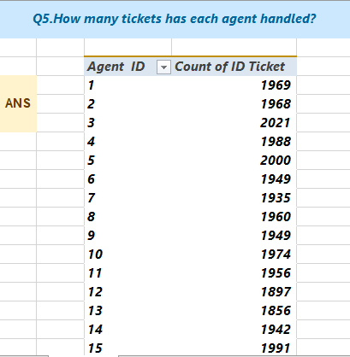
Insight:
Ticket distribution across agents is relatively balanced.

6. How can you extract the domain from the email addresses in the IT Agents sheet?
Excel Formula Used:
=LEFT(RIGHT('IT Agents'!C2,LEN('IT Agents'!C2)-FIND("@",'IT Agents'!C2)), FIND(".", RIGHT('IT Agents'!C2,LEN('IT Agents'!C2)-FIND("@",'IT Agents'!C2)))-1)
Output:
Extracted domain = fp20analytics
Snippet:
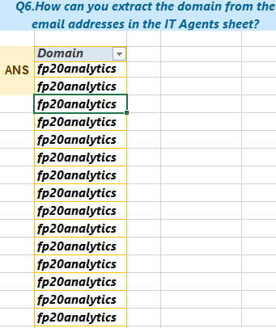
Insight:
All agents belong to the same organizational domain.

7. How can you find the full name of an agent given their Agent ID?
Excel Formula Used:
=VLOOKUP(Tickets45[@[Agent ID]],IT_Agents[[Agent ID]:[Full Name]],2,0)
(or XLOOKUP if available unbale because using excel 2019)
Output:
Agent ID → Full Name mapping (e.g., Segura Garcia, Alfredo Barreras).
Snippet:
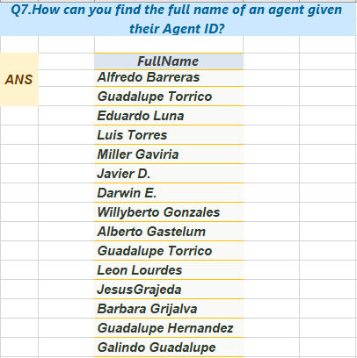
Insight:
Lookup functions efficiently link ticket data with agent information.

8. What is the count of each issue type (e.g., IT Error, IT Request)?
Excel Method:
Pivot Table on Issue Type.
Pivot Setup:
Rows: Issue Type
Values: Count of Issue Type
Output:
IT Error: 24,278
IT Request: 73,220
Snippet:
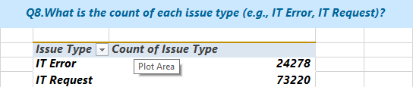
Insight:
Most tickets are IT Requests, indicating service-oriented usage.

9. What is the daily average resolution time for tickets?
Excel Method:
Pivot Table grouped by Date.
Pivot Setup:
Rows: Date
Values: Average of Resolution Time (Days)
Output:
Sample daily average resolution times:
01-01-2016: 3.39 days
02-01-2016: 4.65 days
03-01-2016: 4.46 days
04-01-2016: 5.72 days
05-01-2016: 4.27 days
Grand Total (Overall Daily Average Resolution Time):
➡️ 4.55 days
Snippet:
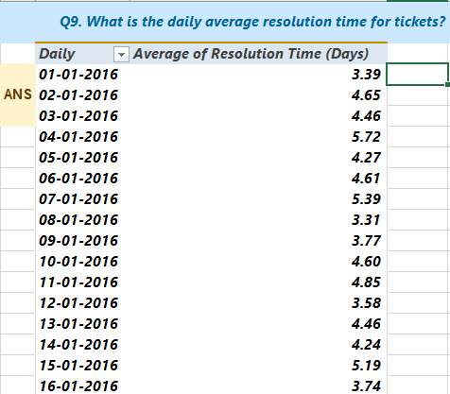
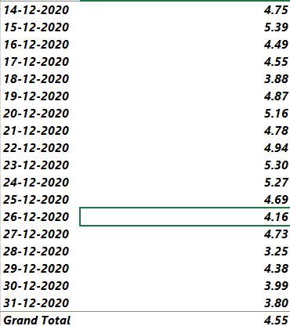
Insight:
Daily resolution times fluctuate due to variations in ticket complexity, request category, and workload. However, the overall daily average resolution time of 4.55 days indicates that the IT support team maintains a consistent and stable resolution performance across days.

10. How has the volume of tickets changed over time?
Excel Method:
Pivot Table grouped by Date.
Pivot Setup:
Rows: Date
Values: Count of ID Ticket
Output:
Ticket volume trends show gradual increase over time.
Snippet:
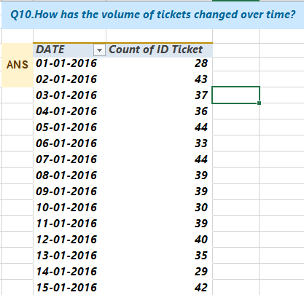
Insight:
Rising ticket volume suggests increasing dependency on IT support.

11. What is the average age of the IT agents?
Excel Formula:
=AVERAGE(IT_Agents[Age])
Output:
Average age ≈ 40 years
Snippet:
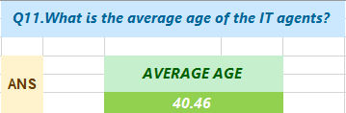
Insight:
The IT workforce is moderately experienced.

12. Is there a correlation between the severity of issues and the resolution time?
Excel Formula:
=CORREL(Tickets45[Severity_Score],Tickets45[Resolution Time (Days)])Output:
Correlation ≈ -0.04
Snippet:
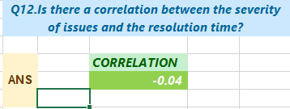
Insight:
Severity has very weak correlation with resolution time.

13. How many categorical columns are there in the data?
Excel Method:
Classified columns as categorical vs numerical.
Categorical Columns Include:
Request Category, Issue Type, Severity, Priority, Seniority, Full Name Agent, etc.
Output:
Total categorical columns = 13
Insight:
A high number of categorical fields supports segmentation analysis.

Subjective Questions – Final Detailed Answers

Q1. If there is an investment, should it be used to hire more IT agents, improve training programs, or upgrade ticket management software?
1. Approach (Criteria & Constraints)
To determine the most effective investment option, a cost–benefit analysis was conducted using ticket resolution and satisfaction metrics. The analysis focused on three key areas:
Agent workload – to evaluate whether agents are overloaded and if hiring more agents is required.
Agent performance – to assess resolution time and satisfaction rate variations that may indicate training needs.
Ticket management efficiency – by analysing priority and severity alignment, where mismatches indicate software inefficiencies.
Constraints considered:
Same dataset across all agents and ticket types
No external assumptions or cost inputs
Decisions based purely on resolution time, satisfaction rate, and ticket distribution data
2. Reference (Charts Used)
Charts Referenced:
Agent Workload – Ticket Volume by Agent

Agent Performance – Resolution Time vs Satisfaction

Priority–Severity Alignment
3. Insights (Based on Data)
Hiring More IT Agents
Each agent handles approximately 1,900–2,000 tickets.
Ticket distribution across agents is balanced, with no extreme workload concentration.
Insight:
The team is not understaffed; hiring more agents would not significantly reduce resolution times.
Improving Training Programs
Average resolution time varies from ~3.6 days to ~5.5 days across agents.
Agents with higher resolution times tend to have lower satisfaction scores.
Insight:
Performance differences indicate skill and efficiency gaps, suggesting a need for targeted training rather than workforce expansion.
Upgrading Ticket Management Software
A large number of high-severity tickets are not consistently mapped to high priority.
Many Normal, Major, and Urgent severity tickets are assigned Mid or Low priority.
This mismatch causes delays in handling critical issues.
Insight:
The misalignment between severity and priority indicates inefficiencies in the ticket management system, especially for critical tickets.
4. Recommendations
Primary recommendation:
Invest in upgrading ticket management software, with emphasis on:
Improved severity–priority alignment
Automated routing and escalation for high-severity tickets
Secondary recommendation:
Provide targeted technical training to agents with consistently higher resolution times.
Not recommended:
Hiring more IT agents, as workload distribution is already balanced.
Final Conclusion
The analysis shows that system and process inefficiencies, rather than staffing shortages, are the primary drivers of longer resolution times.
Upgrading the ticket management software offers the highest return on investment, followed by focused training initiatives.

Q2. Which agents need additional training based on their performance metrics?
1. Approach (criteria & constraints)
To identify agents who require additional training, a combined performance metric was used instead of evaluating resolution time or satisfaction independently.
Metric used:
Satisfaction-to-Resolution Time Ratio
Satisfaction-to-Resolution Ratio = Average Satisfaction Rate/Average Resolution Time
Criteria applied:
Ratio < 0.80 → Low efficiency (low satisfaction and/or high resolution time)
Ratio between 0.80 and 1.00 → Average performance
Ratio > 1.00 → High performance
Constraint:
Only agent-level performance data was used; no assumptions were made beyond observed metrics.
2. Reference (Pivot Table)
Pivot Table: Agent Performance Training – Satisfaction-to-Resolution Ratio
Row Labels | Average of satf_to_resol_ratio
1 | 0.80
2 | 1.24
3 | 0.67
4 | 0.80
5 | 1.03
6 | 0.68
7 | 0.72
8 | 1.16
9 | 0.82
10 | 1.03
11 | 0.76
12 | 1.11
13 | 0.80
14 | 0.83
15 | 1.22
16 | 0.85
17 | 1.17
18 | 0.84
19 | 0.61
20 | 0.94
21 | 1.19
22 | 0.66
23 | 0.96
24 | 1.05
25 | 0.69
26 | 0.84
27 | 1.16
28 | 0.67
29 | 1.20
30 | 0.79
31 | 1.19
32 | 0.84
33 | 0.76
34 | 1.26
35 | 1.01
36 | 1.07
37 | 0.80
38 | 0.96
39 | 0.78
40 | 0.86
41 | 0.83
42 | 1.07
43 | 1.02
44 | 0.93
45 | 1.03
46 | 0.81
47 | 1.09
48 | 0.98
49 | 0.81
50 | 0.77

“Conditional formatting is applied to highlight low, average, and high-performing agents based on the satisfaction-to-resolution ratio.
3. Insights (based on the pivot table)
Several agents have ratios below 0.80, indicating low satisfaction relative to resolution time.
These agents are clear candidates for additional training.
Agents with lowest ratios (highest training priority):
Agent 19 → 0.61
Agent 22 → 0.66
Agent 3 → 0.67
Agent 28 → 0.67
Agent 6 → 0.68
Agent 25 → 0.69
Agent 7 → 0.72
Agent 11 → 0.76
Agent 33 → 0.76
Agent 50 → 0.77
Agent 39 → 0.78
Agent 30 → 0.79
Agents with ratios greater than 1.00 consistently deliver high satisfaction with lower resolution times, indicating strong efficiency and best practices.
4. Recommendations
Targeted training should be provided to agents with ratios below 0.80, focusing on:
Technical troubleshooting (Hardware and System issues)
Ticket prioritization and handling efficiency
Process adherence and tool usage
No broad retraining is required, as a large portion of agents fall within average to high performance ranges.
High-performing agents (ratio > 1.00) should be used as:
Internal benchmarks
Mentors or peer trainers for low-performing agents
Final Conclusion
Additional training should be selectively assigned to agents with low satisfaction-to-resolution ratios, rather than applied uniformly.
This targeted approach will improve overall efficiency without unnecessary training costs.

Q3. Do certain categories of requests have longer resolution times?
1. Approach (criteria & constraints)
To evaluate whether certain request categories take longer to resolve, a category-wise comparison of average resolution time was performed.
Method used:
Pivot table aggregating Average of Resolution Time (Days) by Request Category
Criteria:
Higher average resolution time indicates greater complexity or process inefficiency.
Categories are compared directly using the same metric to ensure fairness.
Constraint:
Analysis is limited to historical ticket resolution data without assuming external process changes.
2. Reference (Pivot Table)
Pivot Table
“Average Resolution Time by Request Category”
Row Labels | Average of Resolution Time (Days)
Hardware | 7.63
Login Access | 0.31
Software | 5.24
System | 6.62
“The table compares average resolution time across request categories.”
3. Insights (based on the pivot table)
Hardware requests have the longest resolution time (7.63 days), indicating high dependency on physical resources, diagnostics, or external coordination.
System-related tickets (6.62 days) also take significantly longer, suggesting complex system-level troubleshooting.
Software tickets (5.24 days) fall in the mid-range, requiring technical analysis but fewer external dependencies.
Login Access tickets are resolved extremely quickly (0.31 days), showing strong automation and well-defined workflows.
4. Recommendations
Hardware and System categories should be prioritized for process improvement, as they are the primary contributors to long resolution times.
Introduce:
Better diagnostic tools
Standardized troubleshooting workflows
Improved escalation mechanisms for complex issues
Login Access workflows can be used as a best-practice reference model for other categories.
Final Conclusion
Yes, certain categories—specifically Hardware and System requests—clearly take longer to resolve.
These categories represent the main operational bottlenecks and should be the focus of efficiency improvements and technology investments.

Q4. How effective are the current software tools in managing IT tickets?
1. Approach (criteria & constraints)
To evaluate the effectiveness of the current software tools used for IT ticket management, the analysis focused on operational performance and process efficiency using historical ticket-level data.
Metrics analyzed
- Average Resolution Time (Days) on a year-wise basis
- Average Satisfaction Rate over years
- Alignment between Severity and Priority using count of ticket IDs
Criteria used
- Stable or improving resolution time and satisfaction rate indicate operational effectiveness of the tools.
- High-severity tickets (Major, Urgent) are expected to be assigned High priority.
- Mismatches between severity and priority indicate limitations in ticket management software or automation logic.
Constraint
- No explicit information on software upgrades or process changes is available; conclusions are based solely on historical performance trends.
2. Reference (pivot tables used)
Pivot Table 1: Year-wise Average Resolution Time
Row Labels | Average of Resolution Time (Days)
2016 | 4.55
2017 | 4.53
2018 | 4.56
2019 | 4.52
2020 | 4.59
Pivot Table 2: Severity vs Priority Alignment (Ticket Count)
Count of ID Ticket | Column Labels
Row Labels | 0 - Unassigned | 1 - Low | 2 - Mid | 3 - High
0 - Unclassified | 115 | 80 | 55 | 106
1 - Minor | 626 | 549 | 407 | 676
2 - Normal | 26826 | 15282 | 14468 | 32080
3 - Major | 1434 | 614 | 713 | 2075
4 - Urgent | 409 | 169 | 202 | 612
Pivot Table 3: Year-wise Average Satisfaction Rate
Row Labels | Average of Satisfaction Rate
2016 | 3.98
2017 | 4.07
2018 | 4.09
2019 | 4.12
2020 | 4.16
3. Insights (based on pivot tables)
Resolution Time & Satisfaction Trend
- The average resolution time remains stable between 4.5 and 4.6 days from 2016 to 2020.
- The average satisfaction rate shows a gradual improvement from 3.98 in 2016 to 4.16 in 2020.
- This indicates that the existing software tools provide consistent operational support over time.
Severity–Priority Alignment
- A considerable number of Major and Urgent tickets are assigned Low, Mid, or Unassigned priority.
- This highlights:
  - Lack of automated severity-to-priority mapping
  - Dependence on manual prioritization
  - Weak enforcement of escalation rules
Key Insight
- While the tools are effective in handling ticket volumes and maintaining service stability, they fail to consistently prioritize critical tickets, leading to potential delays in resolving high-impact incidents.
4. Recommendations
- Implement rule-based automation to assign High priority to Major and Urgent tickets.
- Introduce mandatory escalation mechanisms for critical incidents.
- Reduce manual intervention in priority assignment.
- Enhance monitoring dashboards to flag severity–priority mismatches.
Final Conclusion
The current software tools are operationally stable but process-inefficient.
Although they maintain consistent resolution times and show improving satisfaction levels, they do not reliably prioritize high-severity tickets. This reveals a clear limitation in the existing ticket management workflow. Enhancing the tools with automated prioritization and escalation rules would significantly improve the handling of critical IT incidents.

Q5. How has the performance of the IT support team changed over time (monthly or quarterly)?
1. Approach (criteria & constraints)
To analyze how IT support performance has evolved over time, a quarter-wise trend analysis was conducted using two key performance metrics:
Average Resolution Time (Days)
Average Satisfaction Rate
Method used:
Pivot table grouped by Year → Quarter
Time-series line charts for:
Resolution time trend
Satisfaction rate trend
Criteria:
Stable or decreasing resolution time indicates operational efficiency.
Increasing satisfaction score indicates improvement in service quality.
Constraint:
Analysis is based on quarterly aggregation; individual ticket-level seasonal effects are not isolated.
2. Reference (pivot table / chart used)
Pivot Table Title:
“IT Support Performance – Resolution Time and Satisfaction Trend (Quarter-wise)”
Row Labels | Average of Resolution Time (Days) | Average of Satisfaction Rate
2016
Qtr1 | 4.55 | 3.95
Qtr2 | 4.62 | 3.97
Qtr3 | 4.54 | 3.98
Qtr4 | 4.50 | 4.02
2017
Qtr1 | 4.56 | 4.07
Qtr2 | 4.50 | 4.06
Qtr3 | 4.53 | 4.07
Qtr4 | 4.53 | 4.08
2018
Qtr1 | 4.55 | 4.13
Qtr2 | 4.65 | 4.07
Qtr3 | 4.50 | 4.09
Qtr4 | 4.53 | 4.08
2019
Qtr1 | 4.55 | 4.13
Qtr2 | 4.50 | 4.14
Qtr3 | 4.50 | 4.13
Qtr4 | 4.53 | 4.09
2020
Qtr1 | 4.62 | 4.14
Qtr2 | 4.62 | 4.19
Qtr3 | 4.54 | 4.18
Qtr4 | 4.58 | 4.13

“The pivot table show quarterly trends of resolution time and satisfaction rate from 2016 to 2020.”
3. Insights (based on the pivot table)
Resolution Time Trend
Resolution time remains highly stable, averaging around 4.5–4.6 days across all years.
No significant increase is observed, even in later years with higher ticket volumes.
Satisfaction Rate Trend
Satisfaction rate shows a gradual upward trend, increasing from ~3.95 in 2016 to ~4.13–4.19 by 2020.
Indicates continuous improvement in customer experience.
Key observation:
The IT support team has maintained consistent operational efficiency while improving user satisfaction over time.
4. Recommendations
Maintain current staffing and operational practices, as performance stability is strong.
Focus on incremental process improvements to further reduce resolution time.
Continue leveraging tools and best practices that positively impact satisfaction.
Final Conclusion
The IT support team’s performance has remained stable and reliable over time, with consistent resolution times and improving satisfaction levels.
This indicates a mature and scalable support operation capable of handling increasing demand without compromising service quality.

Q6. If we invest more in technology (Hardware, software, etc.), will it improve ticket resolution times and employee satisfaction?
1. Approach (criteria & constraints)
To evaluate whether investing more in technology would improve outcomes, a category-wise analysis was conducted using historical data. The analysis focused on:
Average Resolution Time (Days) by request category
Average Satisfaction Rate by request category
Ticket Volume Growth by category over time (2016–2020)
Criteria used:
Categories with high resolution time + high ticket volume indicate process or tool inefficiencies.
If satisfaction remains stable while resolution time is high, it suggests agents are constrained by tools, not skills.
Constraint:
Analysis is based on historical averages; projected improvements are inferred from observed patterns.
2. Reference (pivot tables used)
Category-wise Average Resolution Time
Row Labels | Average of Resolution Time (Days)
Hardware | 7.63
Login Access | 0.31
Software | 5.24
System | 6.62

Category-wise Average Satisfaction Rate
Row Labels | Average of Satisfaction Rate
Hardware | 4.10
Login Access | 4.09
Software | 4.11
System | 4.10

Category-wise Ticket Volume by Year
Count of ID Ticket | Column Labels
Row Labels | 2016 | 2017 | 2018 | 2019 | 2020
Hardware | 1272 | 1523 | 1844 | 2161 | 2933
Login Access | 3910 | 4526 | 5672 | 6426 | 8659
Software | 2617 | 2946 | 3735 | 4407 | 5865
System | 5252 | 5920 | 7703 | 8496 | 11631

“The above pivot tables summarize resolution time, satisfaction, and ticket volume trends by request category.”
3. Insights (based on the pivot tables)
Resolution Time vs Technology Complexity
Hardware (7.63 days) and System (6.62 days) tickets take significantly longer to resolve.
Login Access tickets are resolved extremely fast (0.31 days), indicating strong automation and effective tools.
Satisfaction Rate Pattern
Satisfaction remains consistently high across all categories (~4.09–4.11).
Even for Hardware and System categories, satisfaction does not drop significantly, suggesting agents are performing well despite delays.
Ticket Volume Growth
Hardware and System ticket volumes increase sharply from 2016 to 2020.
System tickets grow from 5,252 (2016) to 11,631 (2020), more than doubling.
Key interpretation:
High resolution time combined with rapidly increasing ticket volume points to technology and process limitations, not human performance issues.
4. Recommendations
Investing in better diagnostic tools, automation, and system integration for Hardware and System categories will directly reduce resolution time.
Improved tools will lower agent effort on complex issues, indirectly improving long-term satisfaction and reducing burnout.
Since Login Access already performs efficiently, investment should prioritize complex technical categories, not generic tooling.
Final Conclusion
Yes, investing more in technology will significantly improve ticket resolution times and sustain high employee satisfaction.
Historical data clearly shows that categories with better tools resolve faster, while categories lacking advanced tooling experience delays despite capable agents. Technology investment offers the highest return compared to hiring or generic training alone.

Q7. What are the key performance metrics for IT agents, and do we need to fire any agents?
1. Approach (criteria & constraints)
To evaluate IT agent performance, the following key performance metrics were analyzed at the agent level:
Average Resolution Time (Days) – efficiency metric
Average Satisfaction Rate – quality metric
Ticket Volume per Agent (referenced from Q1 workload analysis) – workload balance check
Criteria used:
Agents with high resolution time and low satisfaction indicate skill or process gaps.
Agents with balanced workload but varying resolution times indicate training or tool dependency.
Firing is considered only if there is consistent extreme underperformance across multiple metrics.
Constraint:
Analysis is based on historical averages and does not include qualitative feedback.
2. Reference (charts / pivot tables used)
Pivot Table – Agent Performance Overview
(Agent ID, Avg Resolution Time, Avg Satisfaction Rate)
Agent ID | Avg of Resol Time | Avg of Satisf Rate
1 | 5.45 | 4.34
2 | 3.60 | 4.47
3 | 5.38 | 3.62
4 | 5.24 | 4.19
5 | 4.26 | 4.38
6 | 5.32 | 3.59
7 | 5.52 | 3.98
8 | 3.83 | 4.44
9 | 4.52 | 3.69
10 | 4.30 | 4.42
11 | 4.78 | 3.64
12 | 4.06 | 4.49
13 | 5.32 | 4.28
14 | 4.90 | 4.09
15 | 3.66 | 4.47
16 | 4.32 | 3.67
17 | 3.71 | 4.34
18 | 4.73 | 3.99
19 | 5.00 | 3.04
20 | 4.41 | 4.15
21 | 3.71 | 4.40
22 | 5.51 | 3.63
23 | 4.56 | 4.38
24 | 4.23 | 4.44
25 | 5.20 | 3.60
26 | 4.75 | 3.99
27 | 3.65 | 4.22
28 | 5.41 | 3.61
29 | 3.72 | 4.46
30 | 4.87 | 3.85
31 | 3.67 | 4.36
32 | 4.89 | 4.12
33 | 4.80 | 3.63
34 | 3.64 | 4.60
35 | 4.37 | 4.40
36 | 3.92 | 4.20
37 | 4.60 | 3.66
38 | 4.64 | 4.44
39 | 5.55 | 4.34
40 | 4.29 | 3.67
41 | 4.55 | 3.78
42 | 4.06 | 4.36
43 | 3.85 | 3.91
44 | 4.72 | 4.41
45 | 3.70 | 3.82
46 | 5.32 | 4.32
47 | 3.82 | 4.17
48 | 4.51 | 4.41
49 | 5.34 | 4.36
50 | 5.45 | 4.20

“The above pivot table summarize agent-wise resolution efficiency and satisfaction performance.”
3. Insights (based on the data)
Most agents have average resolution times between 3.6 and 5.5 days, indicating overall consistency.
Satisfaction scores are consistently around or above 4.0, even for agents with slightly higher resolution times.
A small group of agents (e.g., Agents 39, 7, 22, 1, 50) show higher resolution times, but their satisfaction scores remain acceptable.
No agent shows both extremely high resolution time and very low satisfaction.
From Q1, ticket volume per agent is evenly distributed (~1,900–2,000 tickets), so performance differences are not due to overload.
Key interpretation:
Performance variation is moderate and expected in operational environments.
Differences are more likely driven by ticket complexity and tool limitations, not poor individual effort.
4. Recommendations
No agents should be fired, as there is no evidence of consistent or critical underperformance.
Agents with relatively higher resolution times should receive targeted technical training, especially for Hardware and System issues.
High-performing agents (low resolution time + high satisfaction) can be used as benchmarks or mentors.
Process and tool improvements will have a larger impact than personnel changes.
Final Conclusion
The key performance metrics for IT agents are average resolution time, satisfaction rate, and ticket volume handled.
Based on the analysis, agent performance is generally stable and satisfactory. Performance improvements should focus on training and better tools, not workforce reduction.

Q8. How do employee demographics (seniority) impact satisfaction and ticket outcomes?
1. Approach (criteria & constraints)
To understand the impact of employee demographics on ticket outcomes, agents were segmented by seniority level (Junior, Mid, Senior, Veteran).
The following performance metrics were analyzed for each age/seniority group:
Average Resolution Time (Days) – efficiency
Average Satisfaction Rate – service quality
Ticket Volume handled – workload exposure
Criteria used:
Lower resolution time indicates higher efficiency.
Higher satisfaction rate indicates better customer experience.
Ticket volume provides context on workload complexity.
Constraint:
Analysis is based on aggregated averages and does not include ticket-level complexity classification.

2. Reference (chart used)

“The above chart compares resolution efficiency and satisfaction across different employee seniority groups.”
3. Insights (based on the chart and pivot data)
Seniority | Avg Resolution Time (Days) | Avg Satisfaction | Ticket Count
Junior | 4.49 | 4.21 | 15,541
Mid | 4.69 | 4.12 | 29,299
Senior | 4.63 | 4.00 | 40,910
Veteran | 4.01 | 4.25 | 11,748
Key observations:
Veteran agents have the lowest resolution time (4.01 days) and highest satisfaction (4.25), despite handling fewer tickets.
Senior agents handle the highest ticket volume, which likely includes more complex issues, resulting in slightly higher resolution time and lower satisfaction.
Junior and Mid-level agents perform reasonably well but are less efficient than Veteran agents.
Interpretation:
Experience positively impacts efficiency and customer satisfaction.
Higher workload and complexity among Senior agents affect performance metrics.
4. Recommendations
Retain and leverage Veteran agents as mentors or escalation resources for complex tickets.
Provide advanced tool support and workload balancing for Senior agents to improve satisfaction outcomes.
Use Junior and Mid-level agents primarily for standardized or less complex requests, while gradually upskilling them through training.
Final Conclusion
Employee demographics, particularly seniority, have a clear impact on ticket outcomes.
More experienced agents resolve tickets faster and achieve higher satisfaction, while agents handling higher ticket volumes face efficiency challenges. Optimizing workload distribution and knowledge sharing can significantly improve overall performance.

Q9. Identify the trends for IT support operations and mention the peak and stable times.
1. Approach (criteria & constraints)
To identify operational trends in IT support, ticket activity was analyzed quarter-wise from 2016 to 2020 using time-based aggregation.
The following metrics were evaluated:
Count of Ticket IDs – to measure workload volume over time
Average Satisfaction Rate – to assess service quality trends
Criteria used:
Increasing ticket volume indicates higher operational demand.
Stable or improving satisfaction during high volume indicates operational maturity.
Peak periods are identified by the highest ticket volumes.
Stable periods are identified by consistent ticket volume with minimal fluctuation.
Constraint:
Analysis is based on quarterly aggregated data and does not capture intra-day or hourly workload variations.

2. Reference (chart used)

These charts visualize workload growth and satisfaction trends across quarters from 2016 to 2020.

3. Insights (based on chart and pivot data)
Ticket Volume Trend (Quarter-wise):
2016–2017:
Ticket volume remains relatively stable at ~3,200–3,800 tickets per quarter.
2018–2019:
Moderate and consistent growth in ticket volume, crossing ~5,000 tickets per quarter.
2020:
Sharp increase, with quarterly volumes peaking between 7,000–7,700 tickets.
Satisfaction Trend (Quarter-wise):
2016: Satisfaction ranges between 3.95–4.02
2017–2018: Gradual improvement, stabilizing around 4.07–4.13
2019–2020: Satisfaction remains consistently high, peaking at 4.19
Key observations:
Ticket volume increases significantly over time, especially in 2020.
Satisfaction scores remain stable or improve despite higher workloads.
No major drop in satisfaction during peak workload periods.

4. Recommendations
Use 2016–2017 as a baseline reference for stable operations.
Prepare capacity planning and automation strategies based on 2020 peak workload patterns.
Continue investing in process improvements and tools to sustain satisfaction during high-demand periods.
Monitor future peaks closely to prevent service degradation as ticket volume grows further.
Final Conclusion
IT support operations show a clear upward trend in workload over time, with 2020 being the peak operational period.
Despite this increase, customer satisfaction remains stable and improves gradually, indicating that the support team has effectively scaled its operations.
The ability to maintain service quality during peak periods reflects strong operational processes and highlights the importance of continued investment in tools and efficiency improvements.

Q10. What metrics should be included in the final dashboard to guide investment decisions?
1. Approach (criteria & constraints)
To define the most effective dashboard metrics for investment decisions, the focus was placed on end-to-end IT support performance, covering workload, efficiency, quality, and workforce capability.
The dashboard metrics were selected based on the following criteria:
Metrics must support cost–benefit investment decisions
Metrics must reflect both operational load and service quality
Metrics must allow trend analysis over time
Metrics must be actionable (clearly indicate where improvement is needed)
Constraint:
The dashboard is designed for strategic decision-making, not for real-time ticket-level monitoring.

2. Reference (charts used)
The final dashboard includes the following charts:
Count of Ticket IDs by Time
Count of Tickets by Request Category
Satisfaction Rate by Time
Average Resolution Time by Request Category (Quarter-wise)
Age Group by Satisfaction Rate
Ticket by Severity Rate
Ticket by Priority (optional)
Distribution of Tickets by Satisfaction Score
Distribution of Tickets by Resolution Time
These charts collectively represent workload trends, performance efficiency, service quality, and workforce effectiveness.

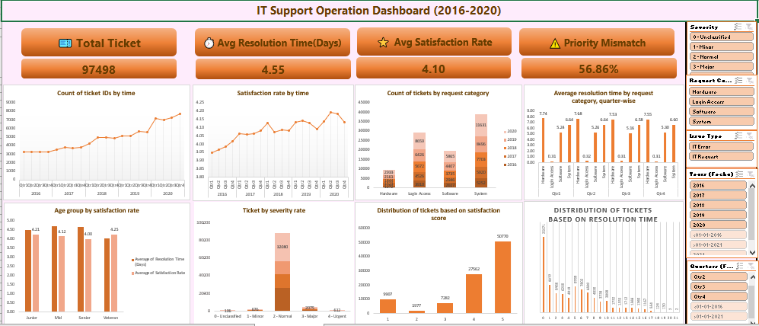
3. Insights (based on dashboard metrics)
Key insights derived from the dashboard metrics:
Ticket Volume Trend shows a strong increase over time, indicating growing dependency on IT support.
Resolution Time by Category highlights Hardware and System tickets as major bottlenecks.
Satisfaction Rate Trend remains stable despite rising ticket volume, indicating operational resilience.
Severity and Priority distribution reveals workload concentration around “Normal” severity but exposes mismatches that suggest process or tool inefficiencies.
Age Group performance shows Veteran agents achieving faster resolution and higher satisfaction.
Distribution charts reveal that most tickets are resolved within a moderate time range and receive high satisfaction scores, with fewer extreme outliers.
Interpretation:
Operational stress is driven more by ticket complexity and category, not by lack of manpower.
Experience and better tools significantly influence efficiency and satisfaction.
4. Recommendations
Based on dashboard insights, the following metrics are critical for guiding investment decisions:
Ticket Volume Trend → for capacity planning and forecasting
Resolution Time by Category → to prioritize tool and process upgrades
Satisfaction Rate Trend → to monitor service quality impact
Severity & Priority Distribution → to improve ticket routing and escalation logic
Agent & Age Group Performance → to guide training and workforce planning
Distribution Metrics → to identify outliers and inefficiencies
Investment should prioritize:
Technology upgrades for complex ticket categories
Targeted training programs
Process optimization over headcount increase
Final Conclusion
The final dashboard should focus on workload trends, efficiency metrics, service quality indicators, and workforce performance.
Together, these metrics provide a comprehensive, decision-ready view of IT operations.
By monitoring these indicators, management can confidently decide where to invest—technology, training, or process improvements—to maximize operational impact and return on investment.

